Task 9.1 NERC

Goal 1: Rule-based NERC, no external knowledge

The rules defines have been defined by looking at the training data, searching the different types (drug, drug_n, brand and groups) and looking for different patterns that are unique or at least usual for each of those.

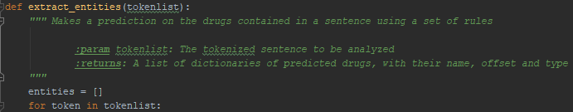
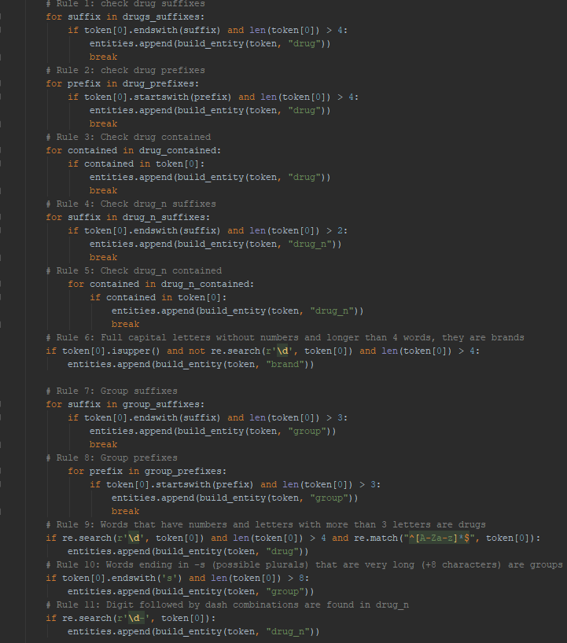

extract_entities accesses the following python file, containing the definition of prefixes, sufixes and substrings:

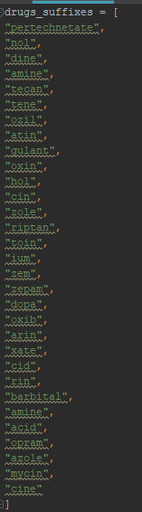
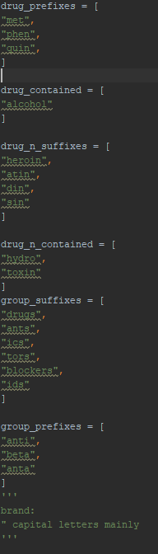

Each rule checks either substrings, prefixes, sufixes or other special rules using these lists, and each element is compared to the given token to check if it fullfills the condition. Other rules checked are the length of a token (mostly to rapidly discard articles, prepositions and other unlikely drug names), and wheter a token contains special characters or upper case.

The above code results in the following evaluation score:

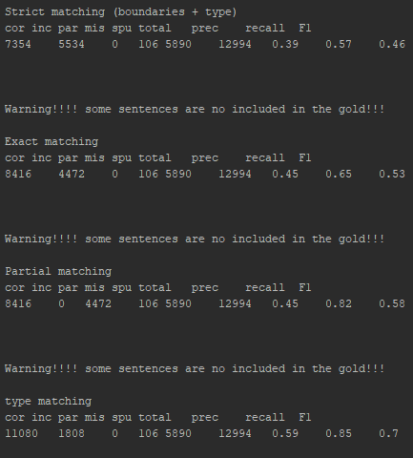
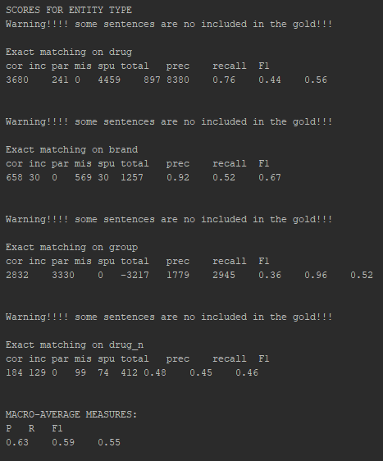
The goal is accomplished, since the final average score is >0.5 (0.55).

Goal 2: Rule-based NERC, with external knowledge

The first external database used to get more drug names that might be missing in the train data (and then appearing later on the test data) is the Orange Book Data: https://www.fda.gov/drugs/drug-approvals-and-databases/orange-book-data-files

Our first approach was to save all the drug names listed in in a PDF within the website into a txt file, which we would use to compare each token, effectively using it as a drug dictionary. However, comparing each token against thousands of names is computationally intensive, and after running it successfully, the score didn't increase enough. Therefore, this approach was scrapped.

The second approach however, was using a list of drug prefixes and sufixes from Drug Information Portal: https://druginfo.nlm.nih.gov/drugportal/jsp/drugportal/DrugNameGenericStems.jsp

The examples found in this website were saved into text files, which are used to make 2 additional rules that compare tokens against this external data. The rules are the following:

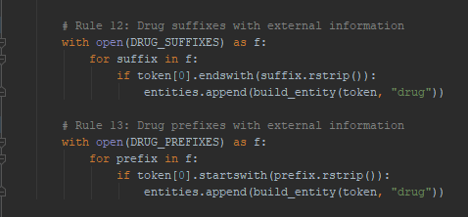
Using these text files ended up improving the evaluation score:

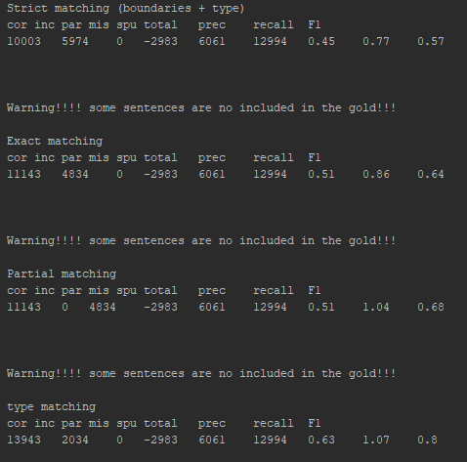
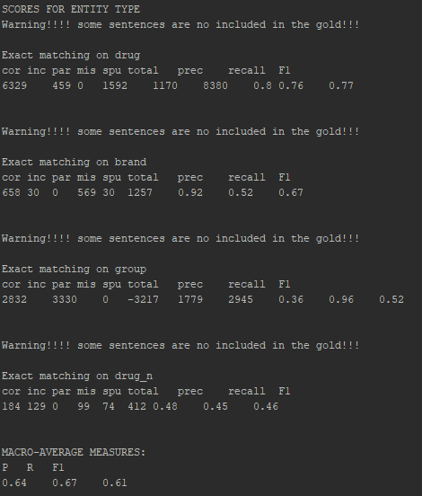
Consequently, the goal 2 was accomplished, as the evaluation score managed to surpass 0.6 (0.61).

Goal 3: Machine Learning NERC, no external knowledge

Goal 4: Machine Learning NERC, with external knowledge

